Design and Implementation of E-project

Specification By

Kazeem Fathiah Ayomide

Kolade OluwaDamilola Jonathan

Obasi Chidubem Richardson

Ogundiran Titobiloba Samuel

Bakerz Bite - Website Documentation

**📌 Project Overview**

Bakerz Bite is a bakery and café website showcasing a variety of baked products, menu categories, team members, testimonials, and contact details. It combines modern design, user interactivity, and mobile responsiveness using HTML, CSS, JavaScript, and third-party libraries.

**🧩 Key Sections & Features**

### 1. Header & Navigation Bar – Overview

The header of the *Bakerz Bite* website is designed with clarity, accessibility, and mobile-responsiveness in mind. It ensures that users can easily find what they’re looking for while highlighting the brand identity.

#### 📌 **Key Features**

1. **Branding Area (Left)**
   * **Logo Icon**: A donut-style bakery icon.
   * **Business Name**: “**Bakerz Bite**” in bold red text with stylized quotes, reinforcing brand visibility.
2. **Navigation Links (Center)**
   * Horizontal menu with clearly labeled sections:
     + **Home**, **About**, **Shop**, **Menu**, **Gallery**, **Team**, **Testimonials**, **Contact, Cart.**
   * Smooth scrolling or navigation to respective page sections or links.
3. **Search Bar (Right Center)**
   * **Placeholder Text**: "Search..."
   * **Magnifying Glass Icon** for universal recognition.
   * Enables **live filtering** or **product search** functionality for improved UX.
4. **Cart Icon (Far Right)**
   * Shopping cart icon with real-time **item counter badge** (currently showing “0”).
   * Navigates to the cart or checkout page.
5. **Mobile Responsiveness**
   * Contains a **hamburger menu** for smaller devices (not visible in the current image but typically part of responsive design).
   * Layout collapses gracefully for mobile and tablet views.



### 2. ****Hero Carousel – Overview****

The Hero section is the first visual element visitors interact with on the homepage. It’s designed to capture attention with vivid imagery and prompt action through clear, motivating text and buttons.

#### 📌 **Key Features**

1. **Rotating Image Slides**
   * Carousel showcases **high-quality bakery images** such as macarons, cupcakes, and pastries.
   * **Automatic sliding** between images or manual navigation using **left/right arrows**.
   * Provides an engaging visual introduction to the brand’s offerings.
2. **Overlay Text Content**
   * **Main Headline**: Bold red text — “Where smiles are served daily.”
     + Emphasizes the emotional and experiential value of the products.
   * **Subtext**: White paragraph — “We Are Here To Provide Our Clients With The Delicious & Tasty Bakery Goods.”
     + Reinforces the brand’s commitment to quality and delight.
3. **Call-to-Action Buttons**
   * **View Menu** (white button with black text)
   * **Contact Us** (red button with white text)
   * These buttons are prominently placed for conversion and interaction.
4. **Navigation Dots**
   * Small dots beneath the carousel provide a visual indicator of the number of slides.
   * Allows users to jump to a specific slide if desired.
5. **Responsive Design**
   * Text and buttons are **centered and layered** over the carousel image.
   * Ensures consistent visibility across desktop and mobile devices.

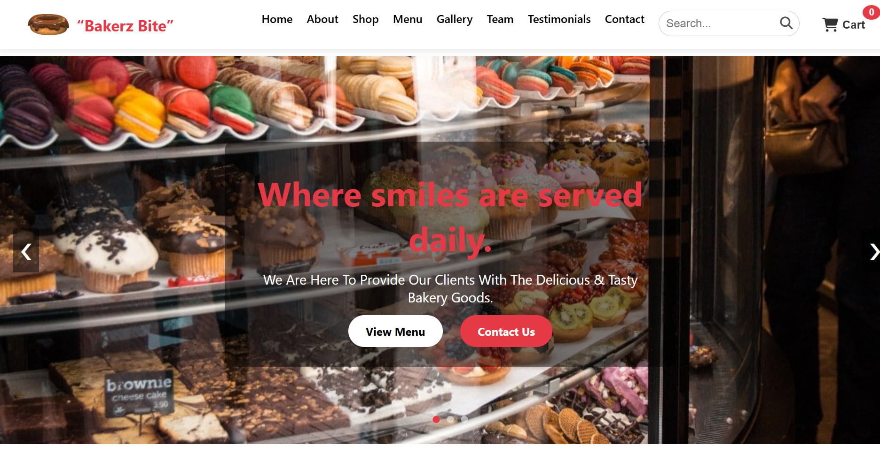

### 3. ****About Us – Overview****

The About Us section is a powerful narrative and trust-building component that combines brand storytelling, milestone achievements, and highlighted services in one visually appealing layout.

#### 📌 **Key Features**

1. **Brand Story with Text and Image**
   * **Descriptive Paragraph**: Introduces Bakerz Bite’s history, core values, and dedication to quality baking.
   * **Accompanying Image**: Typically includes a warm, inviting photo—e.g., bakers at work, shop interior, or a signature product shot.
   * Layout is often split-screen: text on one side, image on the other.
2. **Experience Highlight (Overlay Element)**
   * **“25+ Years’ Experience”** badge or overlay displayed prominently.
   * Reinforces the brand’s **credibility** and **longevity** in the industry.
   * Positioned either directly over the image or as a floating graphic near the top of the section.
3. **Key Service Features (Icons + Text)**
   * **Free Delivery** – Shows commitment to convenience and customer care.
   * **On Time** – Emphasizes reliability and prompt service.
   * **10+ Branches** – Demonstrates the brand’s growth and widespread customer trust.

* These are typically laid out in a **horizontal row** or **3-column grid**, each with its own icon and short label.

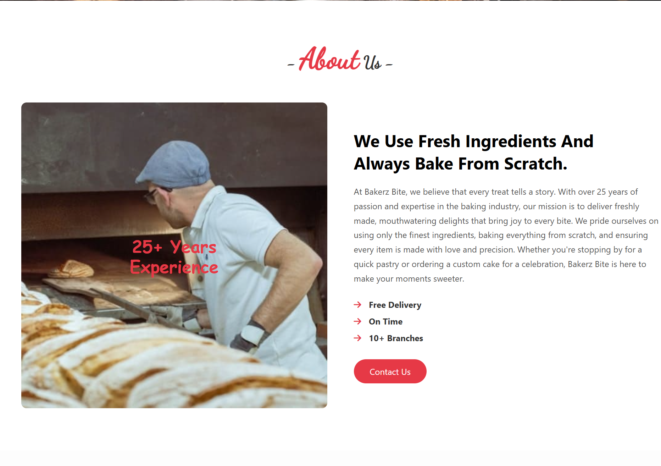

### 4. ****Shop Section – Overview****

The **Shop** section serves as the e-commerce core of the Bakerz Bite website. It allows visitors to browse, select, and purchase bakery products directly from the site with a clean and responsive UI.

#### 📌 **Key Features**

1. **Product List with Images, Prices, and Ratings**
   * **Grid layout** displaying multiple bakery items such as cakes, macarons, and brownies.
   * Each product card typically includes:
     + **Product Image** – High-resolution visuals for appeal.
     + **Product Name**
     + **Price Tag** – Clearly visible currency-based pricing.
     + **Star Rating** – User ratings shown as stars (e.g., ★★★★☆).
2. **‘Add to Cart’ Buttons**
   * Each product has a prominently styled **“Add to Cart”** button.
   * Adds selected item to the cart with quantity tracking.
   * May include feedback (e.g., toast popup or icon shake) upon adding.
3. **Mini-Cart (Side or Dropdown Panel)**
   * Icon in the header reflects real-time **item count**.
   * Clicking opens a **mini-cart overlay** or side panel.
     + **Item List**: Displays product name, quantity, and subtotal.
     + **Total Price**
     + **Checkout Button**: Quick navigation to full cart or payment page.
4. **Responsive and Interactive Design**
   * Fully mobile-friendly: Product cards stack vertically on smaller screens.
   * May include filtering or sorting (optional enhancement).

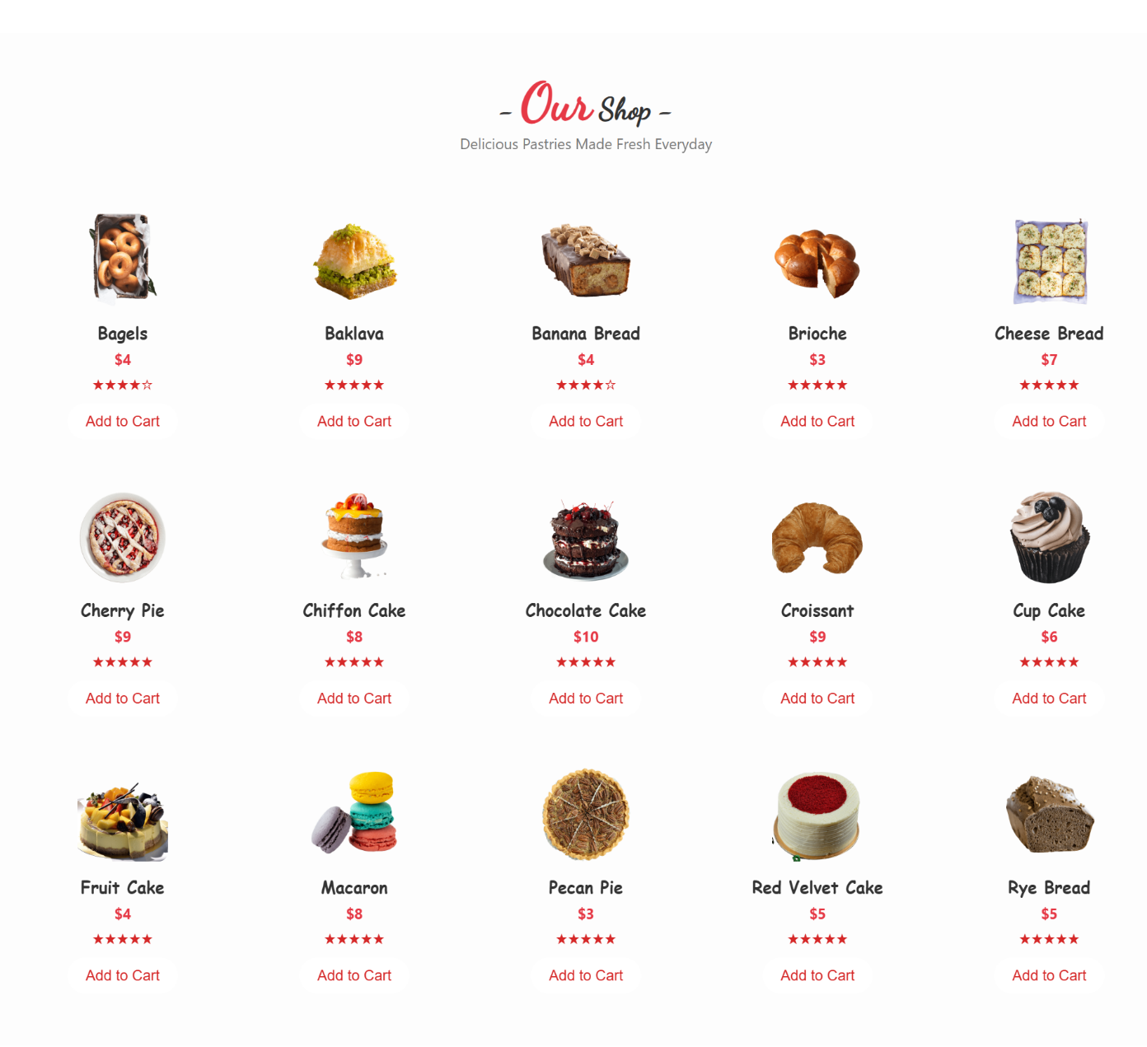

### ****Menu Section – Overview****

The **Menu** section offers a detailed look at Bakerz Bite's product categories, designed to be both informative and interactive. It allows users to explore offerings based on their cravings using visual filters, animations, and clear presentation of item details.

#### 📌 **Key Features**

1. **Filterable by Category**
   * Interactive buttons or tabs to **filter products** by:
     + **Bread**
     + **Cake**
     + **Pastry**
     + **Coffee**
   * Only items from the selected category are displayed, enhancing navigation and user experience.
2. **Item Cards with Descriptions**
   * Each menu item includes:
     + **Product Name**
     + **Short Description** – Flavor profile, texture, or customer favorite tags.
     + **Ingredients List** – Useful for allergy-conscious users, Clicking the image to show it.
     + **Price** – Clearly marked and styled.
3. **AOS (Animate on Scroll) Animation Support**
   * **Smooth scroll animations** triggered as items come into view.
   * Enhances visual engagement using fade-ins, zooms, or slide-ups.
   * Powered by the AOS.js library.
4. **Responsive Design**
   * Grid layout adjusts to screen size (e.g., 2-column on tablets, single-column on mobile).
   * Maintains readability and tap targets for all devices.

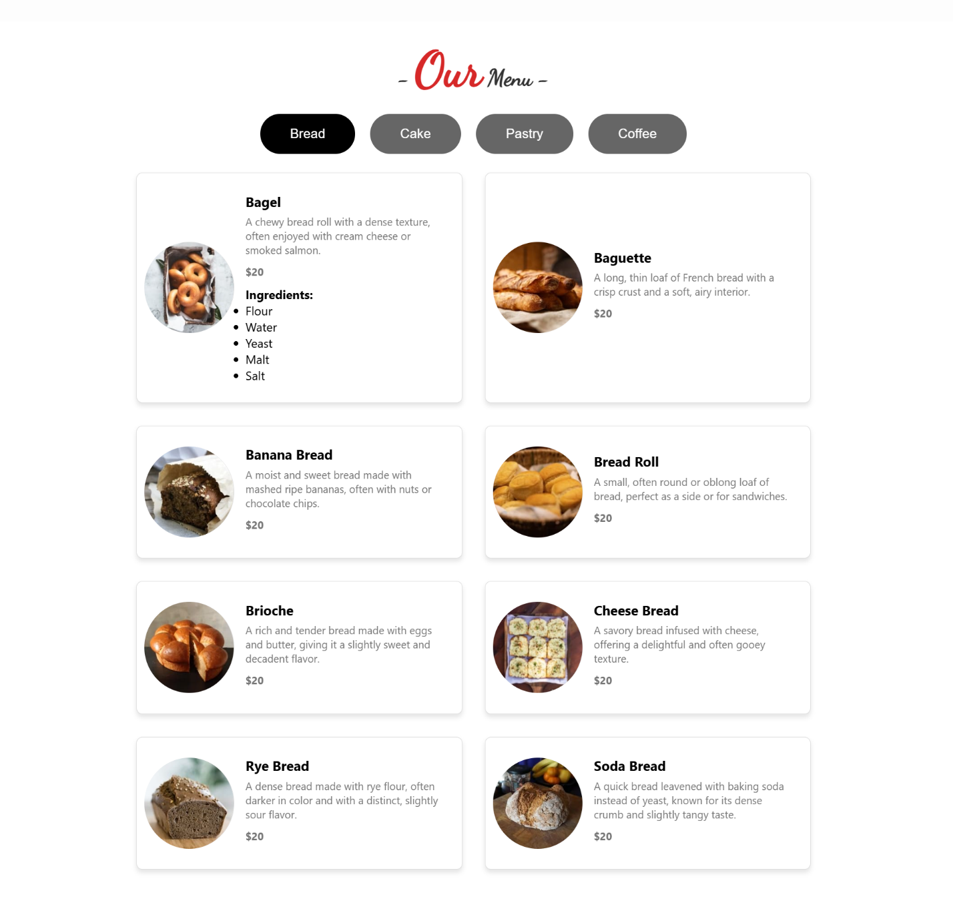

### 6. ****Gallery Section – Overview****

The **Gallery** is a visual showcase of Bakerz Bite's baked goods, store atmosphere, and events. It's designed to be interactive and immersive, allowing visitors to browse and enjoy imagery in an elegant, user-friendly format.

#### 📌 **Key Features**

1. **Filter Buttons**
   * **Category filters** (e.g., *All*, *Cakes*, *Pastries*, *Breads*, *Coffee*) enable users to view specific groups of images.
   * Filter functionality updates the grid in real-time without page reloads.
   * Buttons are styled to show active state (highlighted or underlined).
2. **Image Grid Layout**
   * **Responsive masonry or uniform grid** of thumbnails.
   * Each image is optimized for fast loading but high quality.
   * Hover effects may include zoom-in, dark overlay, or icon indicator.
   * 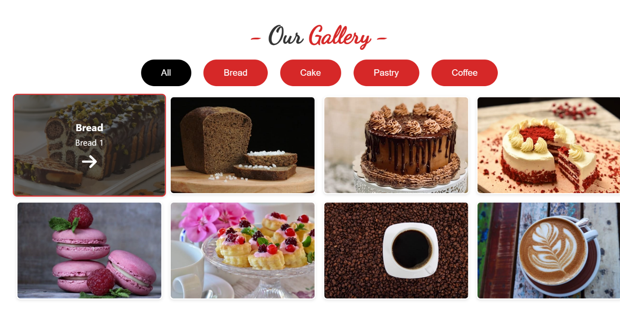
3. **Lightbox Functionality**
   * Clicking an image opens a **lightbox modal** for an enlarged view.
   * Features may include:
     + **Next/Prev arrows** for browsing
     + **Captions or image titles**
     + **Close icon** or clicking outside to exit
4. **Smooth Transitions**
   * Fade or slide animations when opening/closing the lightbox.
   * Ensures a polished and professional browsing experience.

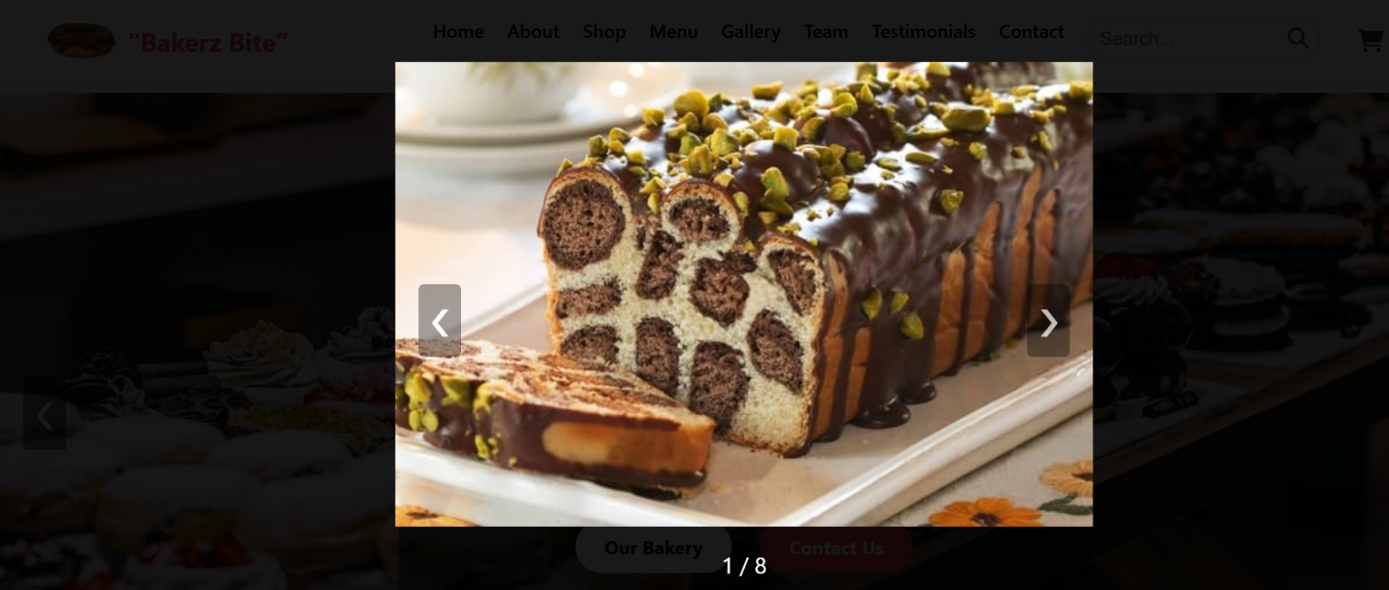

### 7. ****Statistics Counter – Overview****

The **Statistics Counter** section is designed to build trust and showcase business milestones. Using smooth count-up animations, it highlights Bakerz Bite’s growth and success across key metrics.

#### 📌 **Key Features**

1. **Animated Count-Up Effect**
   * Numbers animate from 0 to their final value when scrolled into view.
   * Visually engaging and helps draw attention to achievements.
   * Commonly powered by libraries like **CountUp.js**, **PureCounter.js**, or custom JavaScript.
2. **Key Metrics Displayed**
   * **Products** – Total number of unique bakery items.
   * **Customers** – Count of happy or recurring customers served.
   * **Awards** – Number of industry recognitions or local awards received.
   * **Staff** – Dedicated team members across branches.
3. **Icon + Label Pairing**
   * Each stat is presented with:
     + A **thematic icon** (e.g., cupcake for Products, user icon for Customers).
     + A **title/label** below or beside the count for clarity.
4. **Responsive and Centered Layout**
   * Typically shown in a 4-column layout on desktop, stacked or 2-column on mobile.
   * Clean, consistent styling for easy readability.
5. **Trigger on Scroll**
   * Counters activate only when the section enters the viewport, optimizing performance and enhancing effect.

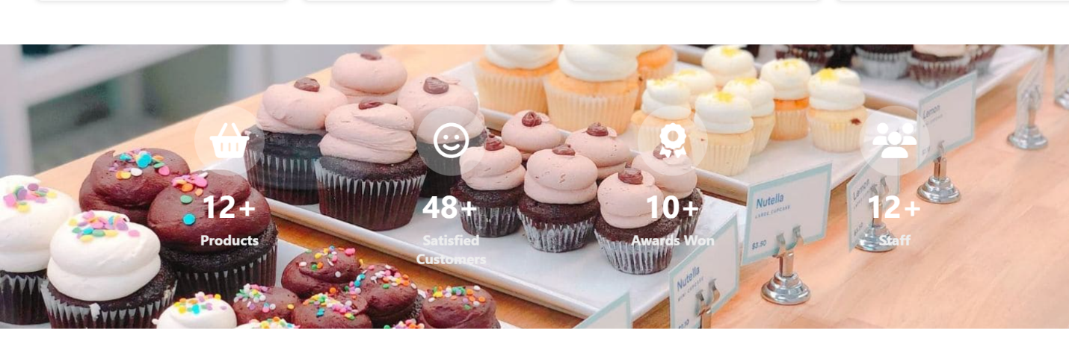

### 8. ****Our Team – Overview****

The **Our Team** section introduces the talented individuals behind Bakerz Bite, building trust and a personal connection with visitors through a visually engaging, social-media-connected layout.

#### 📌 **Key Features**

1. **Team Grid Layout**
   * Structured in a **responsive grid** (e.g., 2x2, 3x3) depending on screen size.
   * Each team member is displayed in a **uniform card** format for consistency.
   * Layout adapts for mobile, stacking vertically for readability.
2. **Team Member Cards**
   * **Profile Image** – High-quality headshot or portrait of each member.
   * **Name & Role** – Clearly displayed below or overlaid on the card.
     + 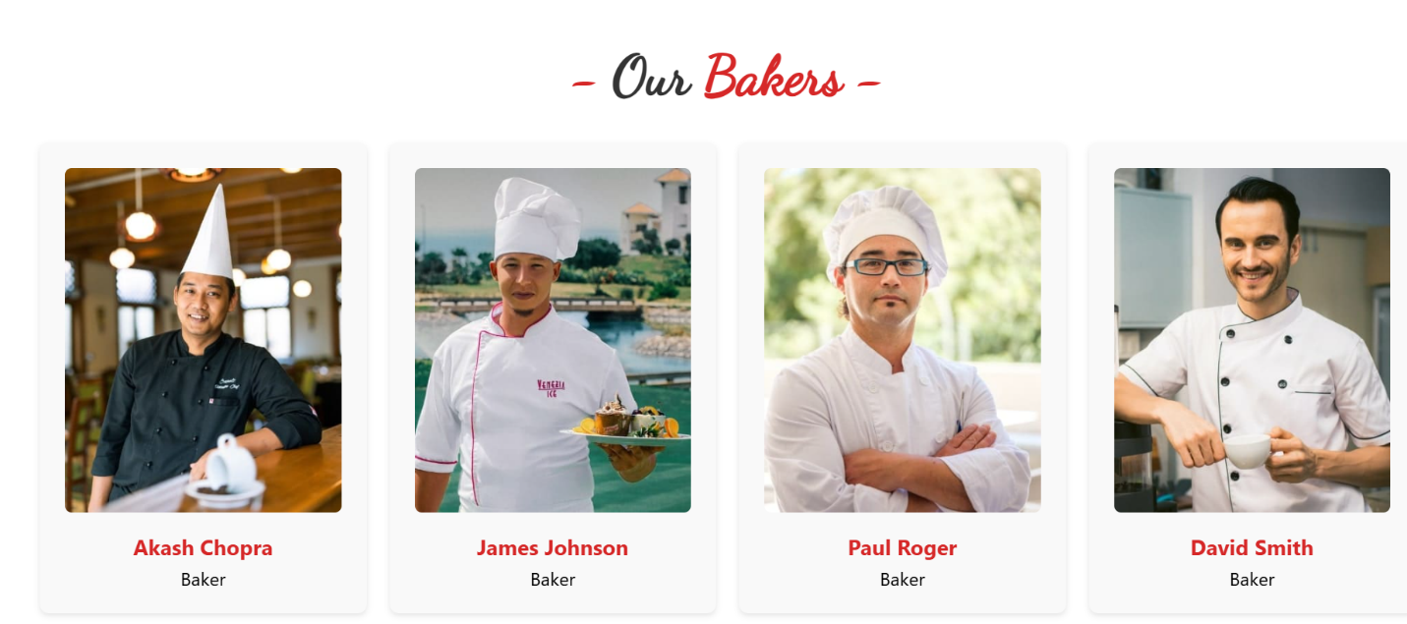E.g., “Sarah J. – Pastry Chef”, “Mark L. – Head Baker”
3. **Social Media Overlay**
   * On hover (desktop) or tap (mobile), an **overlay appears** showing:
     + Icons for social media platforms like Facebook, Instagram, Twitter, LinkedIn.
     + Icons typically animate in with a fade or slide effect.
   * Encourages users to connect or learn more about the team’s professional journey.
4. **Animation Enhancements (Optional)**
   * Entry animations (e.g., fade-in, zoom) for individual cards using AOS or CSS transitions.
   * 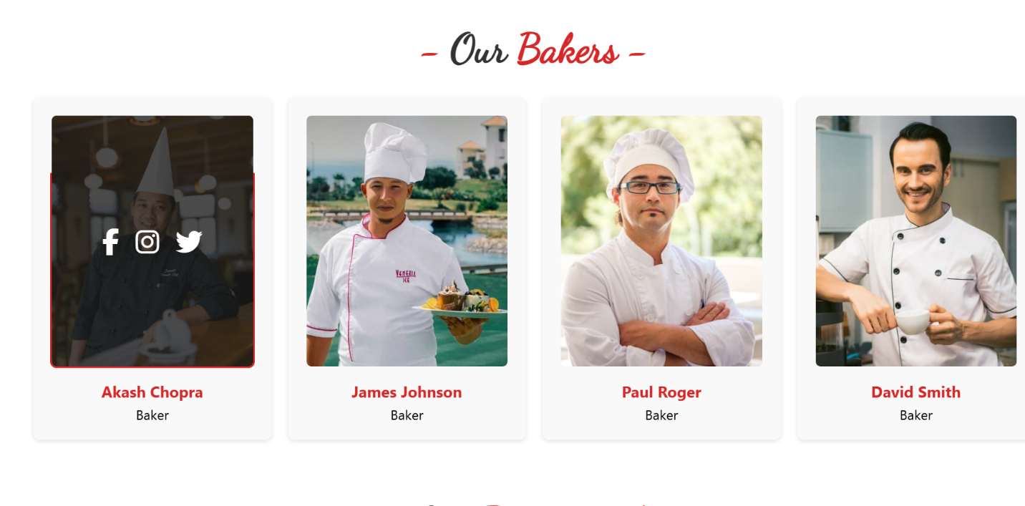Overlay effects using **CSS opacity, transform, or pseudo-elements**.

### 9. ****Testimonials – Overview****

The **Testimonials** section highlights real customer experiences and satisfaction through a rotating carousel format. It reinforces trust and social proof for new visitors and potential buyers.

#### 📌 **Key Features**

1. **Carousel of Feedback**
   * Uses a **sliding carousel** layout to display multiple reviews one at a time.
   * Visitors can **manually navigate** (via arrows or swipe) or let it auto-rotate.
   * Built using tools like **Swiper.js**, **Slick Slider**, **Owl Carousel**, or custom JavaScript.
2. **User Details**
   * Each testimonial includes:
     + **User Image** – Circular or rounded avatar-style photo.
     + **User Name** – Often shown below or alongside the image.
     + **Comment** – Highlighted in a styled quote box or speech bubble format.
3. **Star Rating System**
   * Reviews display a **visual rating** (e.g., ★★★★☆) using star icons.
   * Ratings provide quick insight into user satisfaction.
4. **Clean, Minimal Layout**
   * Testimonial cards have a light background and use padding and rounded corners.
   * Smooth **transition effects** like fade or slide make the experience more dynamic.
5. **Responsive Design**
   * Carousel adapts to all screen sizes.
   * May show multiple testimonials side-by-side on desktop, and one at a time on mobile.

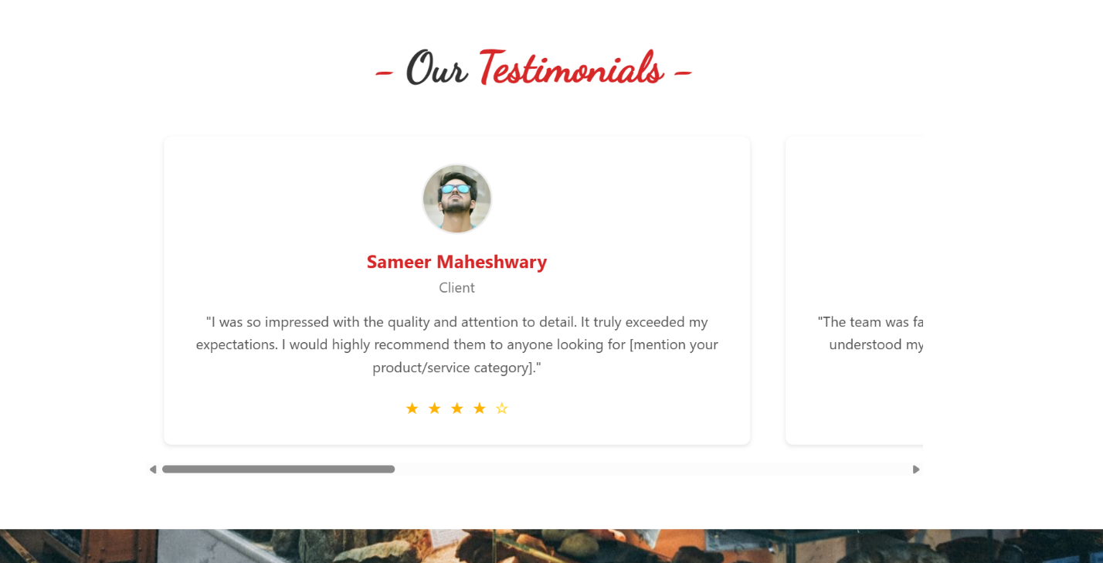

### 10. ****Contact Section – Overview****

The **Contact Section** serves as the communication gateway for users to reach out to Bakerz Bite. It includes both location visibility via Google Maps and a user-friendly contact form for inquiries, orders, or feedback.

#### 📌 **Key Features**

1. **Google Maps Embed**
   * **Interactive map** embedded directly into the page.
   * Displays the **physical location** of *Bakerz Bite*’s main branch or HQ.
   * Users can zoom, pan, and open directions in Google Maps.
   * Typically embedded using an <iframe> with coordinates or address included.
2. **Form spree-Powered Contact Form**
   * Simple, reliable form integration using [**Formspree.io**](https://formspree.io/).
   * Fields usually include:
     + **Name**
     + **Email**
     + **Subject**
     + **Message**
   * Submissions go directly to your email without requiring a backend.
   * May include success/error messages after submission.
3. **Clean, Responsive Layout**
   * Map and form placed side-by-side on desktop, stacked vertically on mobile.
   * Styled with subtle colors, shadows, and spacing for clarity.
4. **Accessibility & Validation**
   * All form fields include proper labels and required field validation.
   * Responsive and keyboard-friendly design.

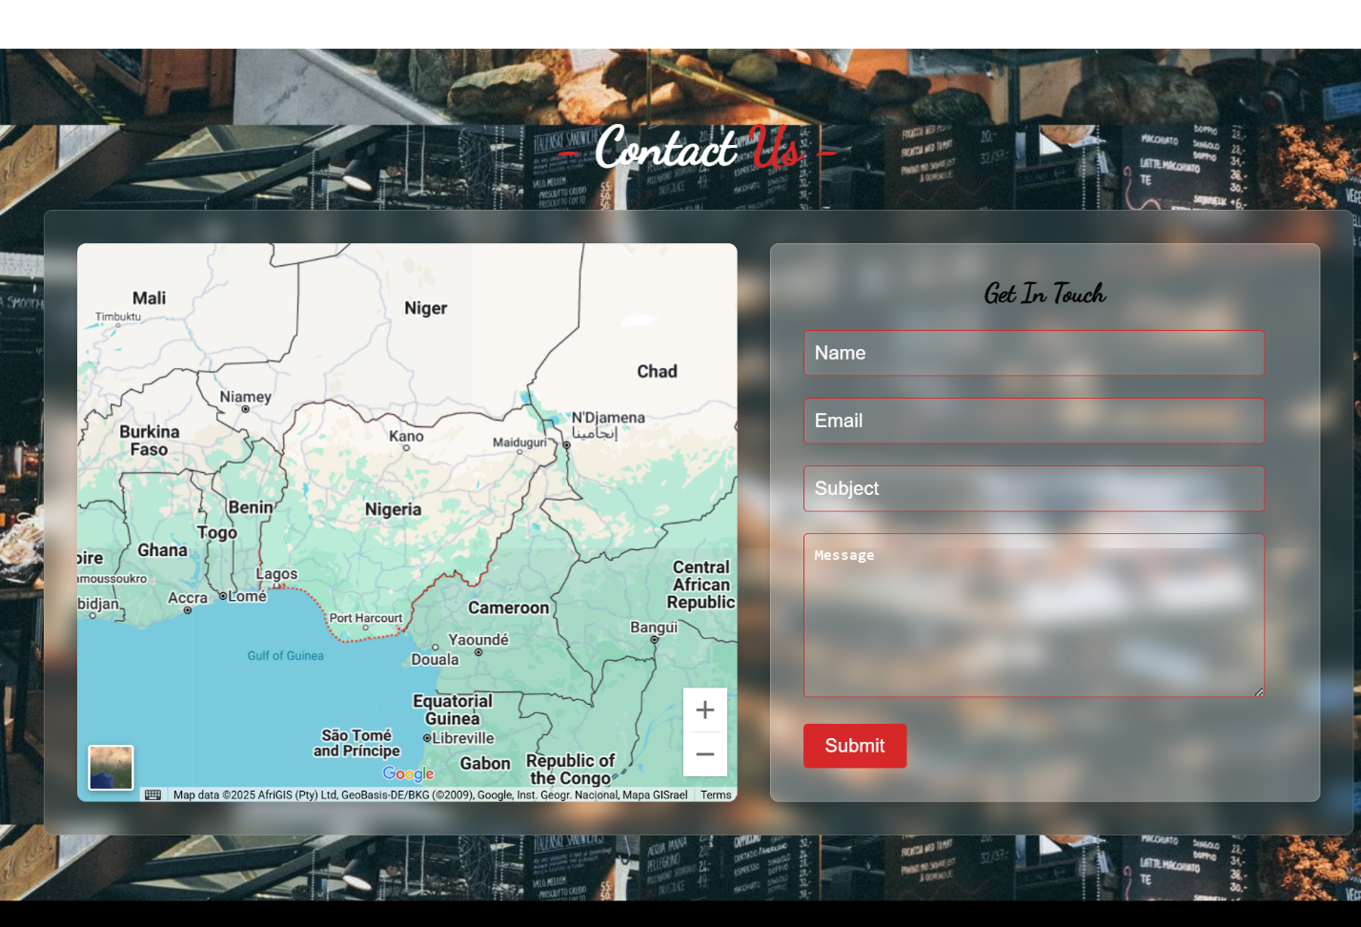

### 11. ****Footer – Overview****

The **Footer** section provides essential closing content for the Bakerz Bite website. It offers users quick access to contact information, navigation, and social platforms, while giving credit to the site’s developer.

#### 📌 **Key Features**

1. **Contact Details**
   * Includes essential business information such as:
     + **Phone number**
     + **Email address**
     + **Physical address**
   * Often accompanied by relevant icons for quick visual scanning.
2. **Quick Links**
   * Mini navigation area for key pages like:
     + Home, Menu, Shop, About Us, Contact
   * Helps users explore more of the site without scrolling back to the top.
3. **Social Media Icons**
   * Clickable icons (e.g., Facebook, Instagram, Twitter, YouTube).
   * Opens social profiles in new tabs.
   * Often styled with hover effects and arranged in a horizontal row.
4. **Developer Credit**
   * Text such as “Developed by [She Code]” or “Crafted with 👩‍💻 by [Developer]”.
   * May include a clickable link to the developer’s portfolio or GitHub.
5. **Responsive & Accessible**
   * Collapses into stacked blocks on smaller screens.
   * Text size, spacing, and contrast are optimized for readability.

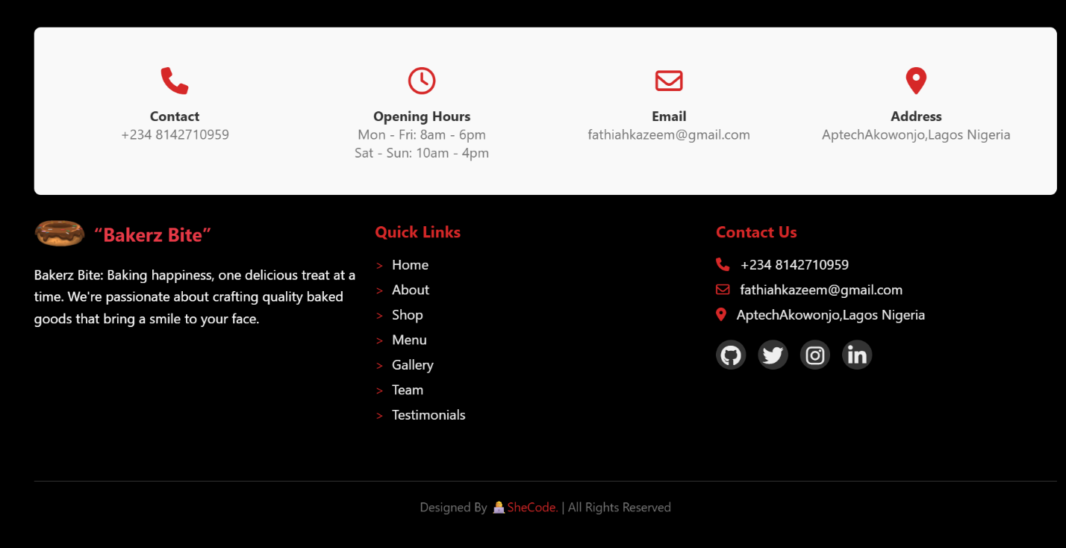

### ****Technologies Used****

This project integrates a modern web development stack to ensure a seamless, responsive, and engaging user experience. Below is a breakdown of the core technologies and tools utilized:

#### 🔧 **Core Technologies**

* **HTML5**  
  Used for structuring the entire layout, providing semantic elements and accessibility.
* **CSS3**  
  Styles the website via an external stylesheet (styles.css) with custom animations, responsive grids, and theming.
* **JavaScript**  
  Powers interactive features and dynamic behaviors through an external script file (script.js).

#### 📚 **Libraries & Tools**

* **AOS (Animate On Scroll)**  
  Enables scroll-triggered animations to enhance visual engagement and section transitions.
* **Font Awesome**  
  Provides scalable vector icons for UI elements such as navigation, social links, and buttons.
* **Google Fonts**  
  Enhances typography by importing custom web fonts for brand-consistent text styling.
* **Formspree**  
  Handles contact form submissions without a custom backend, sending messages directly to your email.

#### 📱 **Responsive Design**

* Built with **mobile-first principles**, ensuring full compatibility across devices (smartphones, tablets, desktops).
* Utilizes flexible grids and media queries for layout adaptation.

### ****12. Cart System – Overview****

The **Cart System** allows users to manage their selected items in real time, enhancing the shopping experience with easy access, clear pricing, and a simple checkout flow.

1. **Mini-Cart Access via Navbar**
   * A **cart icon** is persistently visible in the navigation bar.
   * Displays the **item count** badge dynamically (e.g., 🔢 3).
   * Clicking it opens the **mini-cart panel**—either a dropdown or side panel.
2. **Product Details Displayed**
   * Each added item includes:
     + **Product name**
     + **Price per unit**
     + **Quantity (optional)**
   * Displays a **live-updated total price** at the bottom of the cart.
3. **Remove Item Functionality**
   * Users can easily remove individual items with a small ❌ or trash icon.
4. **Checkout Button**
   * Prominent **"Checkout"** button at the bottom of the cart interface.
   * Clicking it triggers a **confirmation message** like:
     + *“You Checked Out”*
     + May optionally reset the cart or offer a link back to shopping.
5. **Responsive & Interactive**
   * Works smoothly across devices.
   * Built using **JavaScript** to manage cart logic (add/remove items, total calculation, UI toggle).

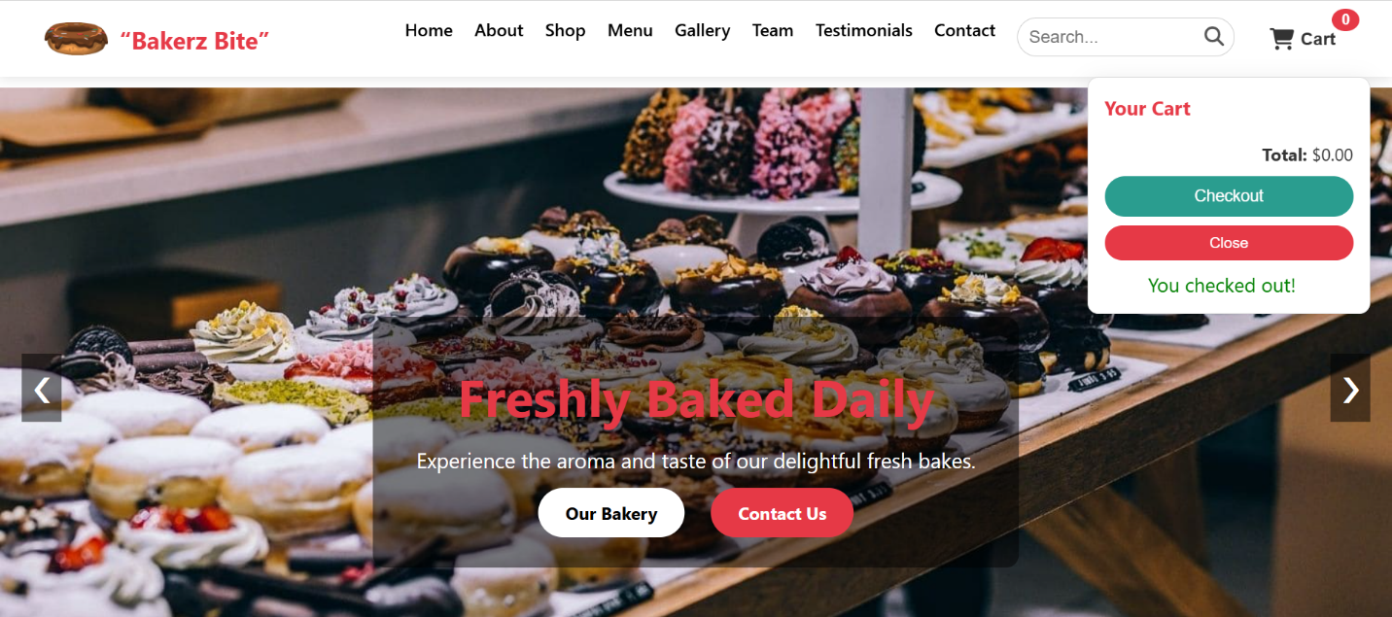

**📍 Contact Info**

* Phone: +234 8142710959
* Email: fathiahkazeem@gmail.com
* Address: Aptech Akowonjo, Lagos Nigeria
* Map Location: Embedded Google Maps iframe (Nigeria)

**📎 Developer Info**

Designed by: 👩‍💻 SheCode

Portfolio: <https://resume-project-n0q3.onrender.com/>

**📈 SDLC Flowchart**

